**Walk 17 Black Hill and Olchon Valley**

Last walked in August 2017

**Description.**  An 8 km (5 mile) with spectacular views from an exhilarating ridge and a marvelous valley descent. An energetic ramble. No stiles. Challenging stepped, terrain ion places. Hereford Times Feb 2016.

**Start.** Picnic Area that is 3½ miles from Longtown heading towards Llanveynoe. Explorer Map OL13. Grid 288327.

**Direction from Tesco’s roundabout** (Turn milometer to zero). Take the A465 to Abergavenny. At 9.7 miles you TR for Longtown 6. At 10.5 miles TL for Longtown 5. At 15.1 miles you TL for Longtown. At 15.3 miles TR at the ‘The Crown Inn’, ***(Established in 1751)***, and head for Longtown Village, a little further on, at the T-Junction you TR for Longtown Castle. Go past the castle heading towards Llanveynoe, and follow Picnic Area signs. At 16.4 miles TL and head for the Picnic area 3m. Go past Llanveynoe church and at 18.3 miles keep R and follow Picnic Area signs ¾m. At 19.1 miles TR and at 19.3 miles you reach the Picnic Area car park.

**1.**  **Black Hill Picnic Area and car park.** You are already at 410m above sea level. Leave the park area away from the approach road via the stile or gate. Go L straight up the obvious ridge along the grassy path between gorse bushes. It’s quite a baptism: the steepest and toughest part of the walk is R here at the start. Take your time and you’ll reach a prow (the pointed front part of a ship) at the bottom/southern end of the very narrow spine. Now keep ahead, with the route becoming more level along a series of craggy stepping stones and recesses. (Spectacular views open out R across Herefordshire and L to Hatterall Ridge). After reaching the king of rocks, the obvious way ahead, along a well worn track, broadens out gently to the summit amid the heather and bilberry.

**2. Black Hill Trig Point.** Trig point is 640m high. From the Trig Point you bear L, north-west, and go past a small pond on your R and along a wide path that goes across typically boggy Black Mountains moorland terrain. It’s a level walk across the plateau and you need to keep going in this direction for 1.2 km. You will reach a junction with a bridle path – and be careful not to miss your turn here!

**3. Cairn.** The junction marker really is just a small pile of stones. Turn very sharp L here for the return leg down thru the Olchon Valley. Follow the faint, narrow grassy path downwards. It soon drops into an obvious depression. The valley opens out spectacularly in front of you. Keep L of the brook. The terrain becomes a rocky track. Eventually it levels out to become more of a grassy track thru Bilberry. Cross a couple of fords and go thru a gate in the corner. Now follow a sunken green lane, which can be muddy to join the narrow country lane.

**4. Olchon Lane.** Follow the lane for 2 km ahead until a L turn takes you quite steeply up to the car park.

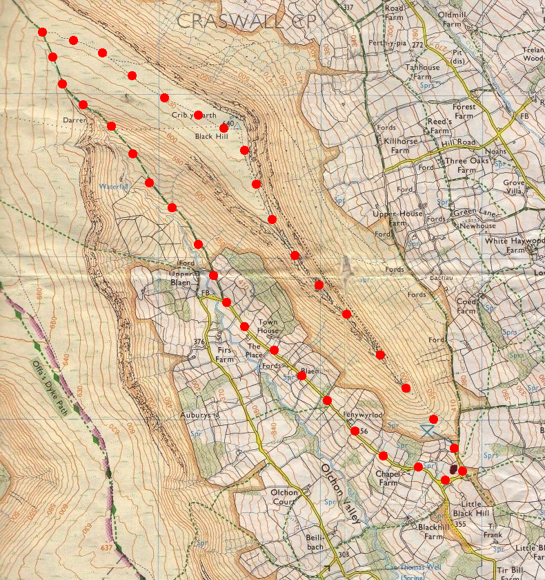

**3**

**4**

**1**

**2**